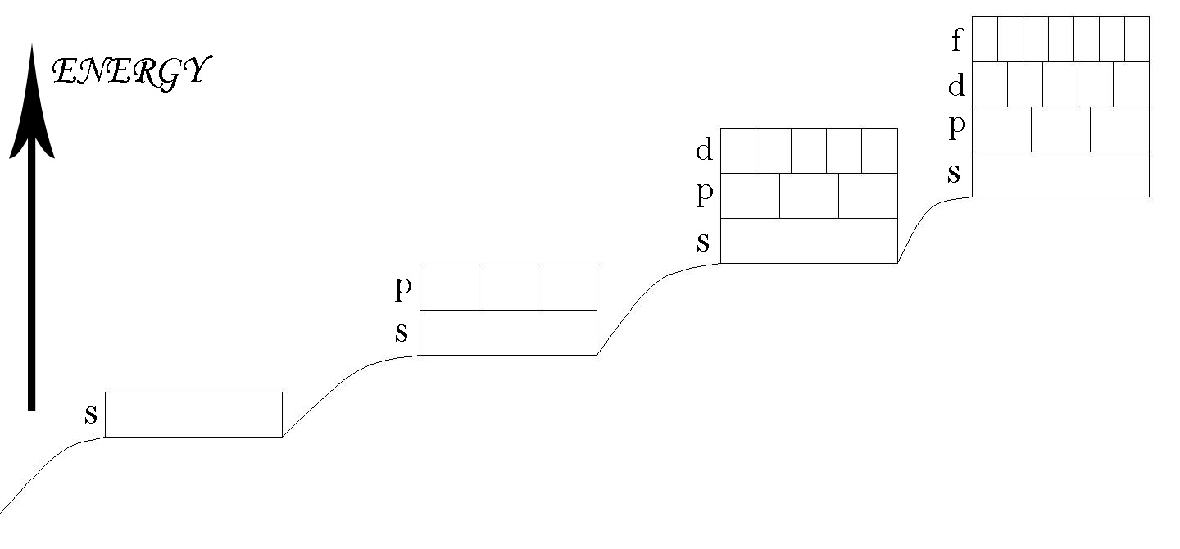
Energy Levels and Electron Configuration

Energy Level | Total Max e- | Subshell | Max e- in subshell | Orbitals in Subshell
1 | 2 | 1s | 2 | 1
2 | 8 | 2s | 2 | 1
2 | 8 | 2p | 6 | 3
3 | 18 | 3s | 2 | 1
3 | 18 | 3p | 6 | 3
3 | 18 | 3d | 10 | 5
4 | 32 | 4s | 2 | 1
4 | 32 | 4p | 6 | 3
4 | 32 | 4d | 10 | 5
4 | 32 | 4f | 14 | 7
Energy Level: Corresponds to rows on Periodic Table. Maximum electrons = 2n² e- in each level = 2n² Maximum number of electrons in each energy level calculated using 2n², where n = number of energy level
Sublevel: Number of sublevels available = number of energy level
Orbital: Space occupied by 2e⁻ found in each sublevel. Orbitals available at each sublevel = n²
Spin: Each electron has + ½ or – ½ spin. + ½ fills orbitals first
Note: n = Energy Levels

Energy Level 4

Energy Level 3

Energy Level 2

Energy Level 1

Aufbau Principle: Building up from lowest energy level/sublevel to highest

Hund’s Rule: Electrons will spread as far apart as possible at each sublevel before pairing.

Pauli Exclusion Principle: No two electrons can be in the same energy level on the same sublevel in the same orbital with the same spin at the same time

